** HEALTHCARE RECORD MANAGEMENT SYSTEM**

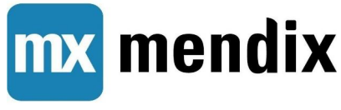 **USING MENDIX**

***Submitted by***

**ARUMUGAM.D 953021106007**

**BUSH KALADEVI.S 953021106013**

**MARI.K 953021106036**

**MUTHUMARI.P.K 953021106045**

**DEPARTMENT OF ELECTRONICS & COMMUNICATION ENGINEERING**



***Guided by***

**MR.M.MUNEESHWAR**



**ST.MOTHER THERESA ENGINEERING COLLEGE**

BONAFIDE CERTIFICATE

Certified that this project report on **HEALTHCARE RECORD MANAGEMENT SYSTEM USING MENDIX** is the Bonafide record of work done by ARUMUGAM.D (953021106007), BUSH KALADEVI.S (953021106013), MARI.K (953021106036), MUTHUMARI.P.K (953021106045), as a team from the Department of Electronics and Communication Engineering, St. Mother Theresa Engineering College, Anna University.

**Internal Guide Head of the Department**

**Internal Examiner External Examiner**

**TABLE OF CONTENTS:**

|  |  |
| --- | --- |
| **S.NO** | **CONTENTS** |
| 1. | INTRODUCTION ABOUT MENDIX |
| 2. | ABSTRACT |
| 3. | INTRODUCTION TO PROJECT |
| 4. | KEY FEATURES OF A MENDIX-BASED HEALTHCARE RECORD MANAGEMENT SYSTEM |
| 5. | PROJECT IMPLEMENTATION |
| 6. | DESIGN OUTPUT |
| 7. | CONCLUSION |

INTRODUCTION ABOUT MENDIX

Mendix is a low-code development platform that allows users to build applications with minimal hand-coding. It's designed to help developers and business users collaborate more effectively by using a visual, drag-and-drop interface to create apps quickly, without needing extensive coding knowledge. Mendix supports the creation of web and mobile applications and integrates various backend systems.

**Key Features include:**

Visual Development:

Mendix uses a model-driven development approach, allowing users to visually model business logic, user interfaces, and data models.

Agile Development:

Teams can iterate quickly, make changes on the fly, and continuously deploy and improve applications in an agile workflow.

Multi-Cloud Deployment:

Applications built on Mendix can be deployed across different cloud providers or on-premises infrastructure.

Integration Capabilities:

Mendix supports REST, SOAP, OData, and other integration methods, allowing it to connect with existing systems.

Collaboration Tools:

It encourages collaboration between developers, business analysts, and stakeholders with built-in feedback and project management tools.

Extensibility:

Developers can extend the platform with custom code (Java or JavaScript), widgets, and APIs when needed.

Mendix is commonly used for business process automation, customer-facing applications, and innovation projects because of its ability to reduce time-to-market. It has also gained popularity due to its flexibility in supporting both experienced developers and less technical users.

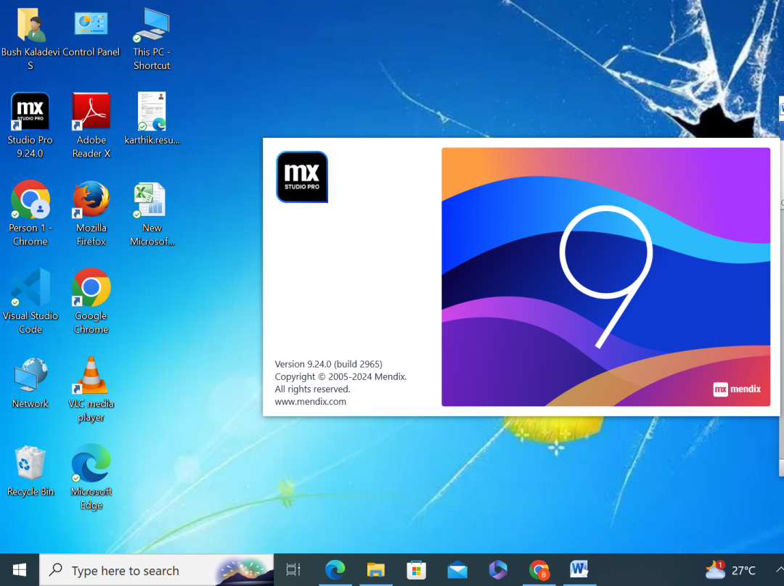

**HEALTHCARE RECORD MANAGEMENT SYSTEM**

**ABSTRACT**

The healthcare industry faces numerous challenges, including regulatory compliance, data silos, and inefficient processes. Mendix, a low-code rapid application development (RAD) platform, addresses these challenges by enabling healthcare organizations to quickly design, build, and deploy customized digital solutions. This abstract explores Mendix's potential in healthcare, highlighting its benefits, success stories, and future directions. The main objective of this project is to define data structures for collecting, storing, and analyzing business data. Design a user interface for data visualization, dashboard creation, and ad-hoc query building. Implement data processing pipelines for ETL (Extract, Transform, Load) tasks, data cleansing, and enrichment. Integrate with external data sources, APIs, and databases for importing and exporting data. Develop reporting capabilities for analyzing trends, patterns, and insights from the analyzed data.

INTRODUCTION TO PROJECT

Mendix's low-code platform revolutionizes healthcare by enabling rapid development of innovative, patient-centered solutions. Healthcare organizations leverage Mendix to create customized applications that streamline clinical workflows, enhance patient engagement, and improve outcomes. With Mendix, healthcare providers can easily integrate electronic health records (EHRs), telemedicine platforms, and wearable device data to deliver personalized care. By empowering non-technical healthcare professionals to build and deploy solutions, Mendix accelerates digital transformation in healthcare, driving better patient experiences, improved operational efficiency, and reduced costs. It is a broad term encompassing the diagnosis, treatment, and prevention of illness and disease. It's a vital human need, ensuring individuals have access to the necessary resources to maintain their physical and mental well-being.

**KEY FEATURES OF A MENDIX-BASED HEALTHCARE RECORD MANAGEMENT SYSTEM**

**Core Features**:

1. Electronic Health Records (EHRs):

Digital storage of patient medical history.

1. Patient Registration:

Secure and efficient patient data management.

1. Document Management:

Store, manage, and retrieve medical documents.

1. Clinical Decision Support:

Integrated decision-making tools.

1. Medication Management:

Track prescriptions, dosages, and allergies.

1. Lab Results Integration:

Streamline lab result processing.

1. Radiology Integration:

Access imaging results.

1. Secure Messaging:

HIPAA-compliant communication.

**Mendix-Specific Features:**

* Low-Code Development: Rapid application development.
* Visual Modeling: Intuitive, model-driven design.
* Agile Deployment: Fast, flexible deployment options.
* Integration with Existing Systems: Seamless connectivity.
* Customizable Workflows: Adapt to unique clinical processes.
* Real-Time Analytics: Data-driven insights.
* Mobile Accessibility: Access patient records on-the-go.
* Scalability: Handle growing patient volumes.

**Security and Compliance Features:**

* HIPAA Compliance: Adherence to healthcare regulations.
* Data Encryption: Protect sensitive patient information.
* Access Controls: Role-based permissions.
* Audit Trails: Track system activity.
* Backup and Recovery: Ensure data integrity.

**User Experience Features:**

* Intuitive Interface: Easy navigation.
* Personalized Dashboards: Customizable views.
* Search Functionality: Quick patient record retrieval.
* Alerts and Notifications: Real-time updates.
* Collaboration Tools: Secure communication.

**Benefits:**

* Improved Patient Care
* Enhanced Clinical Decision-Making
* Increased Efficiency
* Reduced Errors
* Better Data Management
* Compliance with Regulations
* Scalability and Flexibility
* Cost Savings

**PROJECT IMPLEMENTATION**

**STEPS TO IMPLEMENT A HEALTHCARE RECORD MANAGEMENT SYSTEM USING MENDIX**

* **Project Setup and Planning:**

Create a New Mendix App: Start a new Mendix app specifically for your Healthcare Management System.

* **Build the User Interface:**

Design intuitive user interfaces for different user roles:

**Patient portal:** For patients to view appointments, medical records, and communicate with providers.

**Doctor portal:** For doctors to manage schedules, access patient records, and input treatment plans.

**Administrative portal:** For administrators to manage user accounts, billing, and system settings.

Use Mendix's drag-and-drop interface to create forms, grids, and charts.

* **Implement Core Functionalities:**

• User Authentication and Authorization:

o Implement secure login and password mechanisms. o Define roles and permissions for different user types (patients, doctors, admins).

• **Appointment Scheduling**:

o Create a user-friendly interface for scheduling appointments.

o Implement reminders and notifications.

• **Teleconsultation Module:**

o Integrate a reliable video conferencing solution.

o Ensure secure and reliable communication channels.

o Consider features like screen sharing, file sharing, and chat.

• **Medical Record Management**:

o Implement secure storage and retrieval of patient medical records.

o Ensure compliance with data privacy regulations.

* Integration with External Systems:

• **Payment Gateway**: Integrate a payment gateway for online payment processing.

• **Calendar Integration**: Integrate with calendar systems (e.g., Google Calendar, Outlook) for appointment synchronization.

• **EHR Integration:** Integrate with existing Electronic Health Record (EHR) systems to share patient information.

* **Test and Deploy:**
  + - Thoroughly test the application to identify and fix bugs.
    - Deploy the application to a suitable environment.
    - Consider using Mendix's cloud deployment options for easier management and scalability.

**Step 1:**

**Set Up Your Mendix Environment:**

1. **Sign Up for Mendix:**

• Go to the Mendix website and sign up for an account if you don’t have one already.

1. **Install Mendix Studio Pro:**

• Download and install Mendix Studio Pro, which is the desktop application used for development.

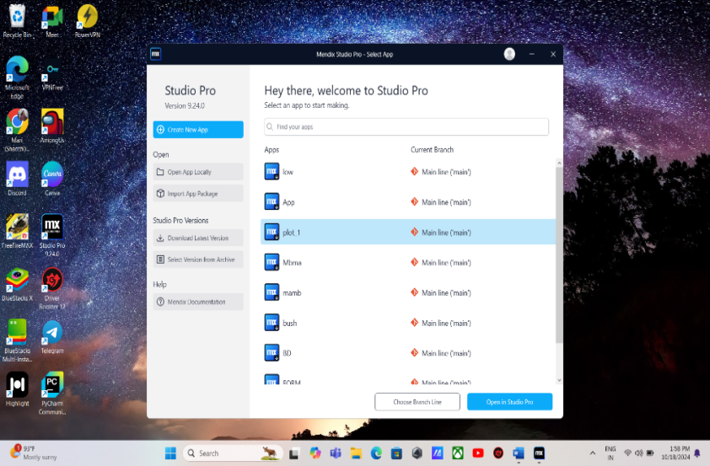

**Step 2:**

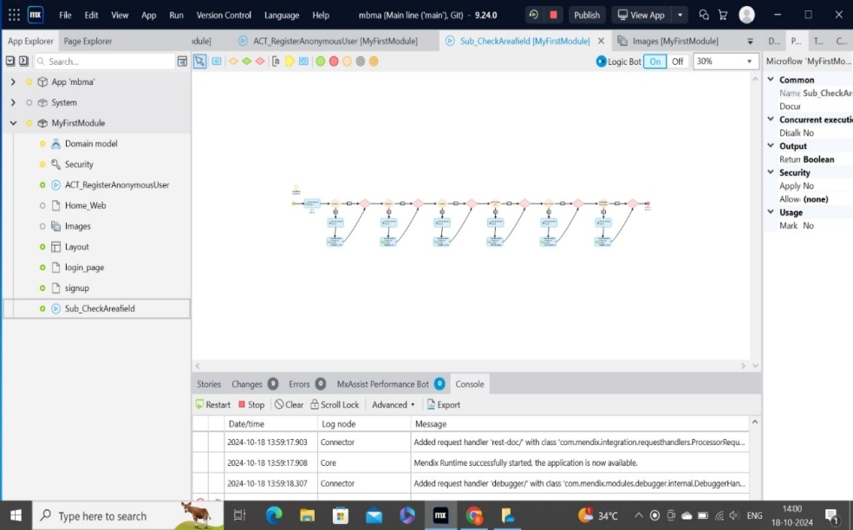 Creating micro flow for our Healthcare Record Management System

**Step 3:**

Writing code for Healthcare Record Management System Webpage

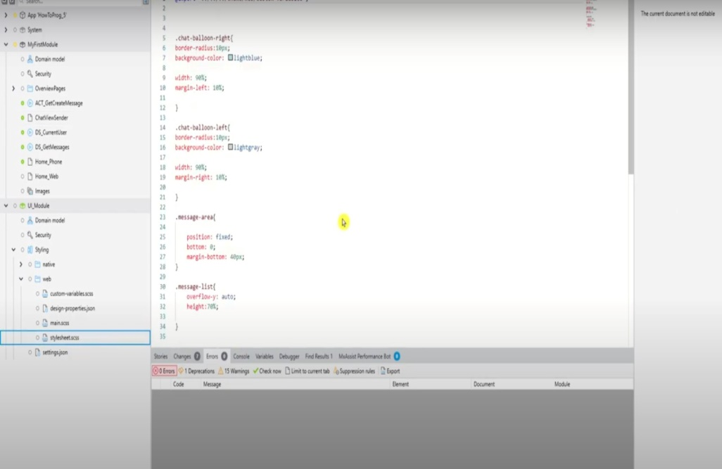

**Step 4:**

Farming entities and association for our Healthcare Record Management System

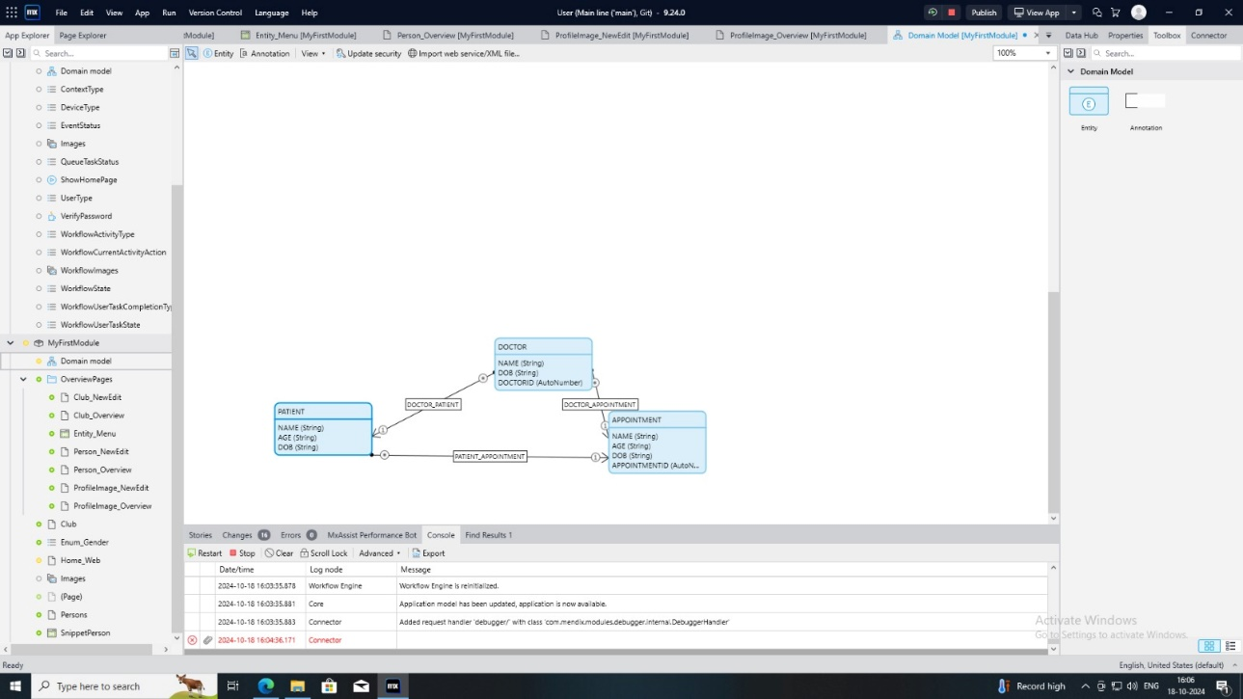

**Step 5:**

The initial page is Patient Registration and getting appointment with Consultation Doctor.

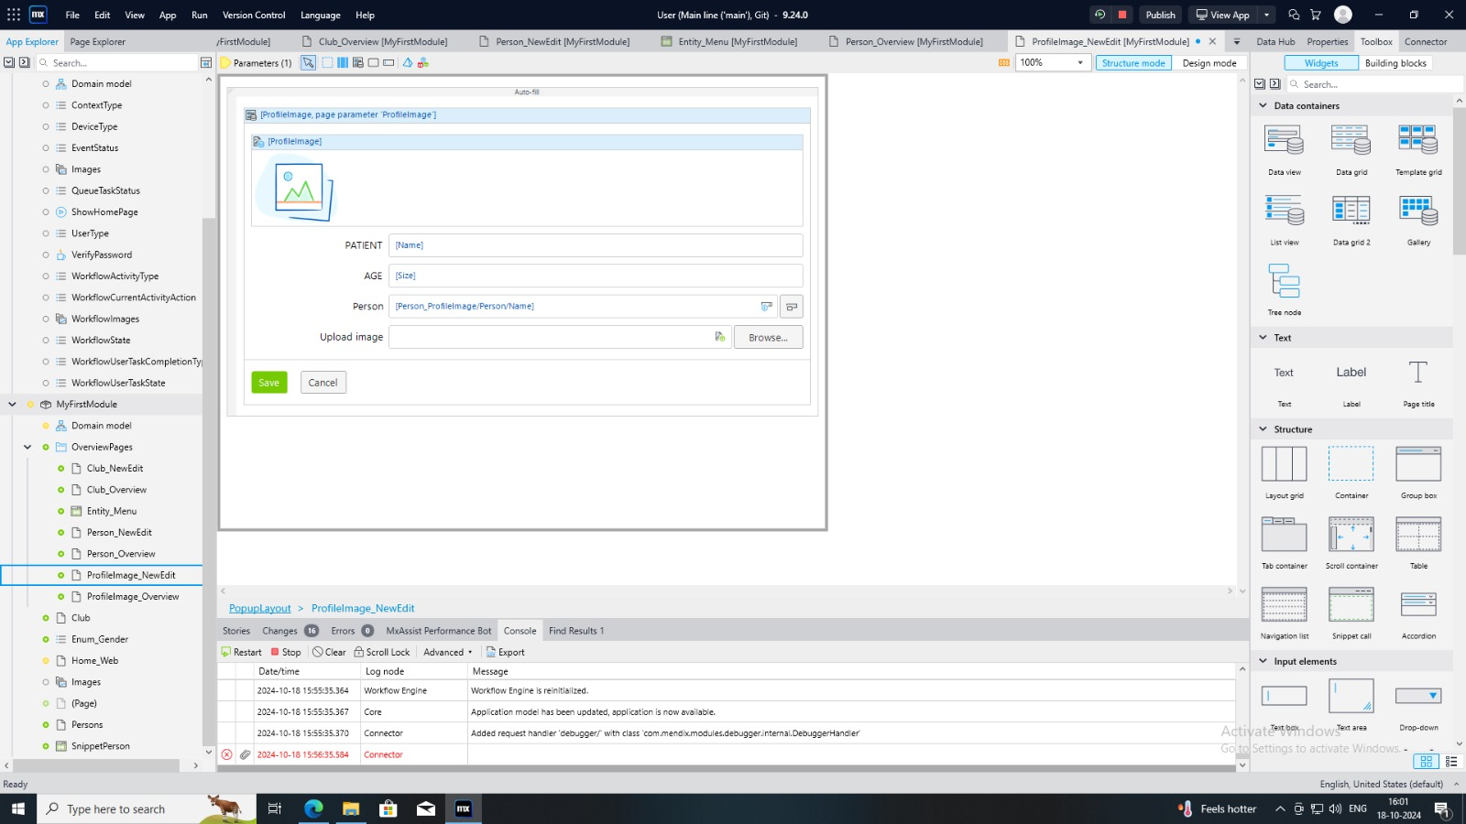

**Step 6:**

Inspecting the sign in page.

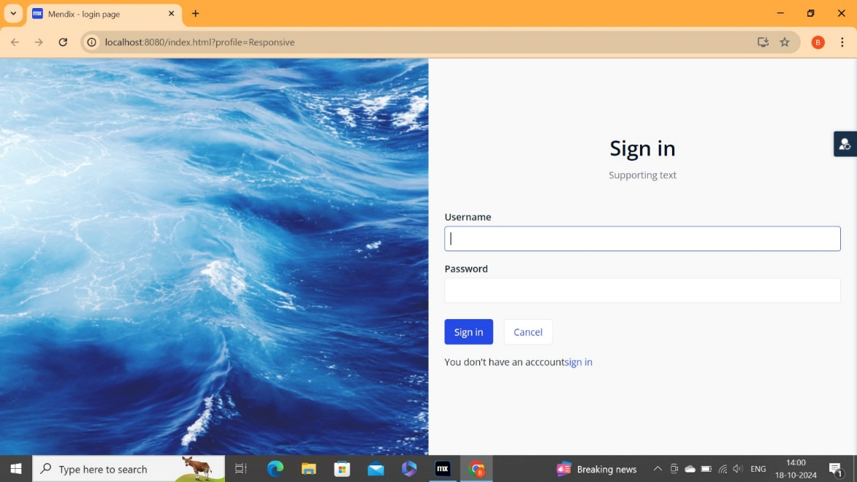

**DESIGN OUTPUT**

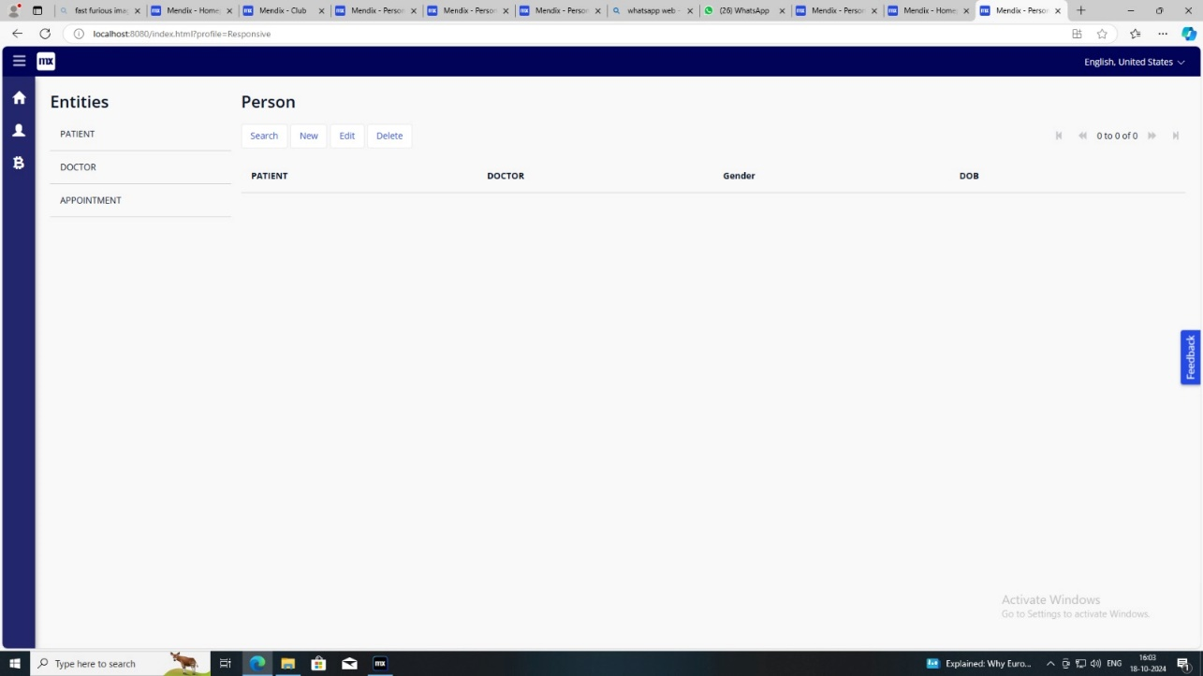

HOME PAGE

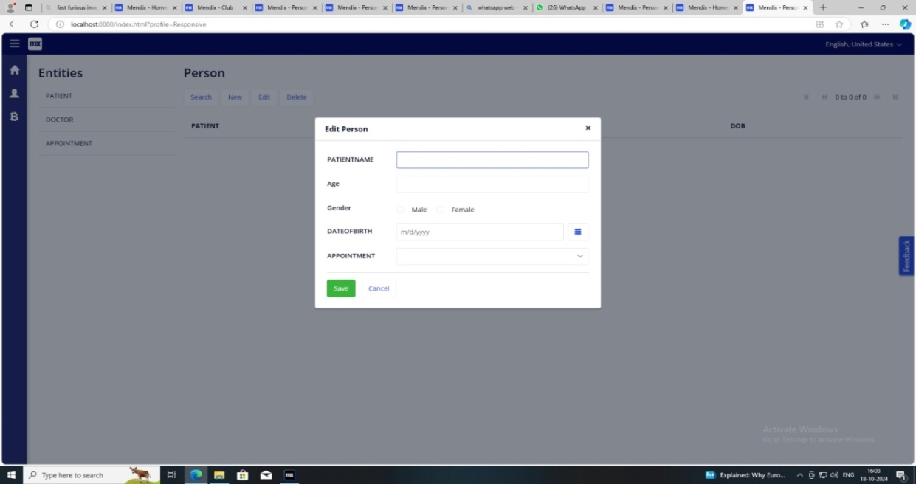

PATIENT REGISTRATION

CONCULSION

In conclusion, using Mendix in healthcare allows organizations to quickly adapt to evolving demands, integrate with legacy systems, and deliver user-centric solutions that drive better health outcomes while optimizing operational efficiency. A Mendix-based Healthcare Record Management System offers a robust, scalable, and secure solution for managing patient records, streamlining clinical workflows, and improving patient care.